HANYANG UNIVERSITY ERICA · OFFICE OF INTERNATIONAL AFFAIRS
2026 Hanyang ERICA Winter School
January 17 – January 31, 2027 | Ansan, Korea
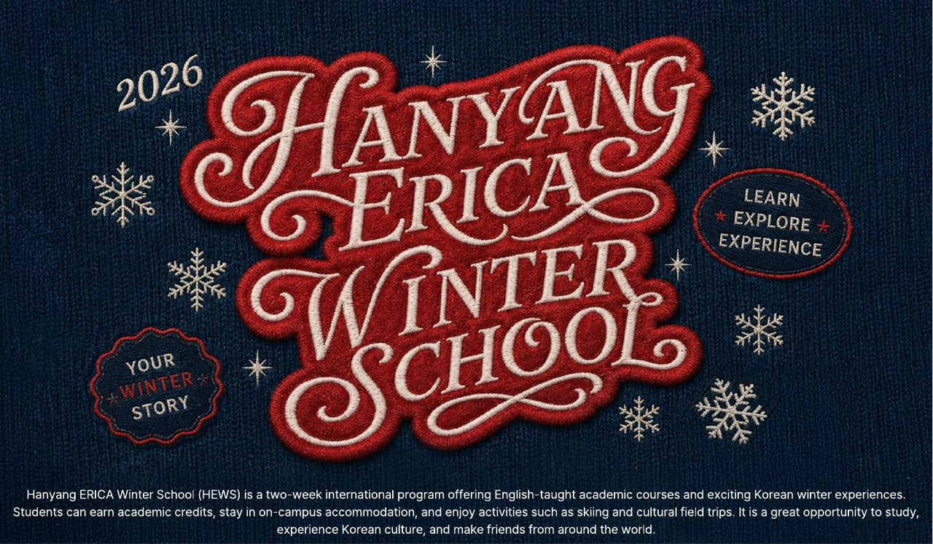
Hanyang University ERICA invites students from our partner universities to spend two weeks in Korea this winter — English-taught credit courses, on-campus housing, a day on the ski slopes and a day at Everland.
Questions? Write to hews@hanyang.ac.kr
Brochure (Linktree)

Brochure (Baidu) password: HEWS

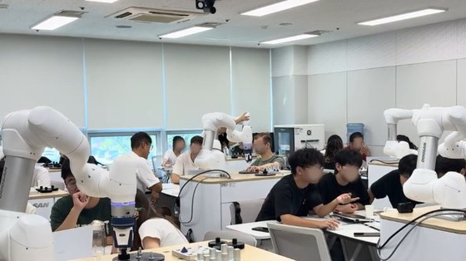  2 weeks, up to 4 credits  January 17 (Sun) – January 31 (Sun), 2027, on the ERICA Campus in Ansan — 40 minutes from Gangnam. Take one 3-credit course plus an optional 1-credit course. Everything is taught in English, except the Korean language class. | 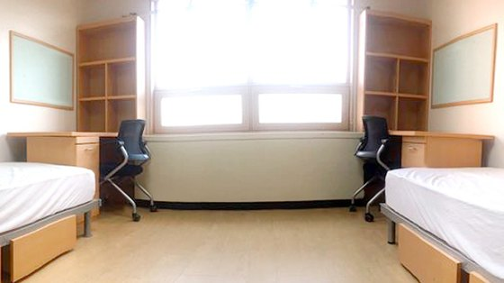  Stay on campus  A twin room in the on-campus dormitory for the full two weeks, included in the program fee. Convenience store, study room, laundry, fitness center and food court are all a short walk away.

What you'll study
3-credit course  Understanding K-Pop Business  Consumer Psychology  Designing the Future: Creativity with Generative AI  Media & Entertainment Business  Robotics  Understanding AI  Semiconductor Engineering | 1-credit course (optional)  K-Pop Dance  K-Pop Vocal  Taekwondo  Samulnori  Basic Korean Language

Two free activities
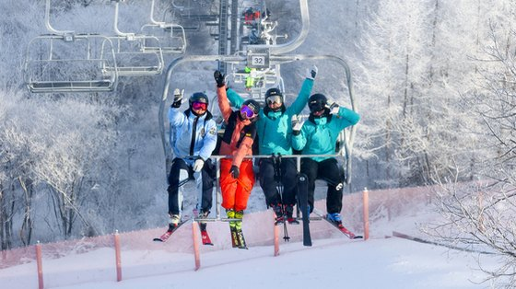  Korean ski experience  A day on the slopes, beginners welcome. |   Everland  Korea's largest theme park, dressed for winter.

How to apply  Applications are open from October 1 to November 30, 2026 at https://linktr.ee/ericasummerschool  Create an account, submit your application, and payment instructions will follow by email. You will then receive a student ID number for online course registration. | Early Bird — save KRW 100,000  Apply online by October 31 and pay by November 6, 2026 (KST).

Program fees
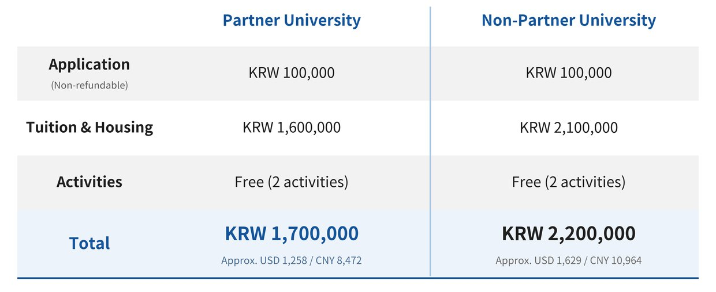
The fee covers the application fee, tuition with on-campus housing, and both activities. Meals, insurance and airfare are not included.
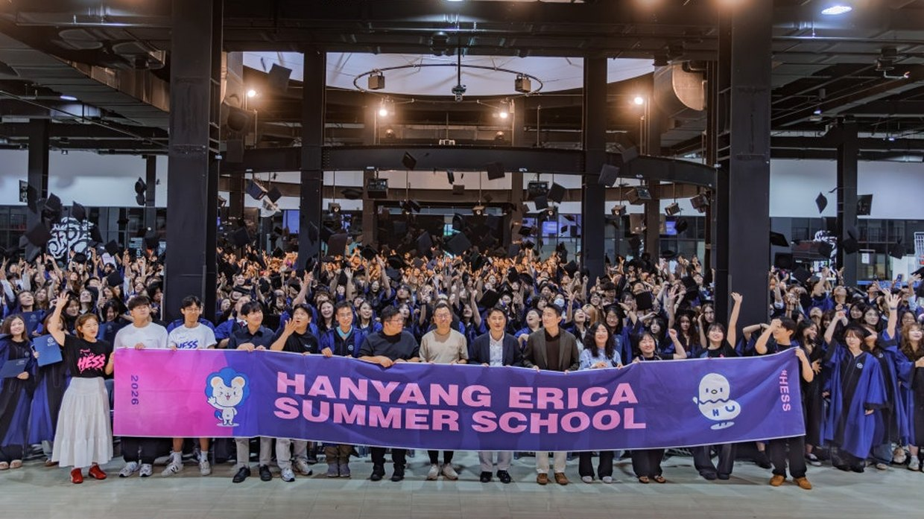
Students from around the world at a Hanyang ERICA closing ceremony
No nomination needed — just apply and join us!
Apply for HEWS 2026

Instagram hanyang_erica_summerwinter
Xiaohongshu (小红书) HYUERICAHESS
WeChat (微信公众号) HYUERICAHESS
Hanyang University ERICA · Office of International Affairs
55 Hanyangdaehak-ro, Sangnok-gu, Ansan, Gyeonggi-do 15588, Korea
+82-31-400-4931 / 4924 / 4917 | hews@hanyang.ac.kr

--

